 |  | OOP | Sample documentation, 2nd assignment | 1.
 | Mahammad Isayev |  | 2. assignment/3. task | 7th April 2021
 | VF36R7
 | vf36r7@inf.elte.hu
 | Group 1

Task

3 . At every competition of the National Angling Championship, the results of the
competitors were recorded and put into a text file. Every line of the file contains the name
of the angler the ID of the competition (string without spaces), and the species and the
size of the caught fishes (pair of a string without spaces and a natural number). Data is
separated by space or tab. The lines of the file are ordered by contest ID. The file is
assumed to be in the correct form. Sample line in the file:
Peter LAC0512 carp 45 carp 53 catfish 96
(1) Give the angler with the corresponding contest ID who has caught the biggest catfish
(it is possible that no one has caught catfish).
(2) List those contests where catfishes bigger than 30 cm were caught.
(1) First part

Plan of the main program:

A = ( f : infile(Line), l : , elem: Contest )

Line = rec (angler : String, contest: String, catches : Catch*)
Catch = rec (species : String, size : ℕ)
Contest = rec (angler : String, contest : String, counter : ℕ)

New state space:

A = ( t : enor(Contest), l : , elem : Contest )

Pre =( t = t’)
Post =( , = ( . ≥ 2))
∈ ′

l:=false; t.first()

l t.end()

l, max := false, 0 2, t.current()

t.next()

Analogy: linear search, custom enumerator
- ~ Contest
 | OOP | Sample documentation, 2nd assignment |  |  |  | 2.
Enumerator of Contests¹
 |  | enor(Contest) | first(), next(), current(), end()
 |  | f : infile(Line) | first() | ~ next()
 |  | cur : Contest | next() | ~ see below
 |  | end : | current() ~ return cur
 |  |  | end() | ~ return end
 |  | Status = { norm, abnorm }

In enor(Contest), operations first() and next() are the same. They have to solve the following task: read the next line of the textfile (f sequential input file). If there is no more, then vaiable end gets true. If there is any, the current angler’s name and the contest ID can be extracted. Then, the ”catfish” species can be counted in the catches..
_{A}next | = ( f: infile(Line), cur : Contest, end : )
Pre^{next} = ( f = f’ )
Post^{next} = ( sf, df, f = read(f’) end = (sf=abnorm)
end → cur.angler = df.angler cur.contest = df.contest
 | cur.counter = ∑ | ∈[1..| . ℎ |] | 1 )
 | . ℎ [ ]. =" ℎ"
 | sf, df, f : read
 | end := sf=abnorm
 | end
 | cur.angler, cur.contest := df.angler, df.contest
 | cur.maxx := 0 | SKIP
 | i = 1 .. ∣df.catches∣
 | df.catches[i].species = ”catfish” and size > cur.maxx
 | Cur.maxx = size | SKIP
Analogy: counting, on interval enumerator
t: [m .. n ] ~ i : [1 .. |df.catches|]
cond(i) | ~ df.catches[i].species=”catfish”
c | ~ cur.bigger
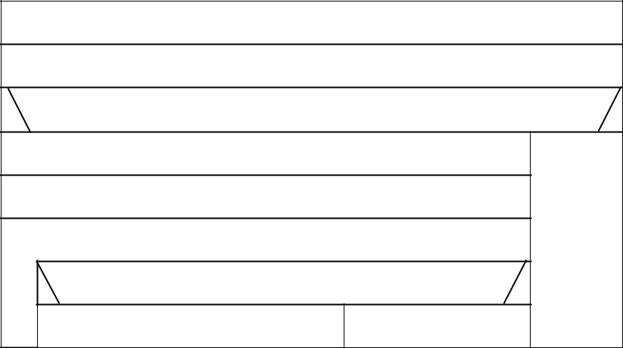

- The enumerator should be in a separate compilation unit.

OOP Sample documentation, 2nd assignment 3.

(2) Second part

Plan of the main program

A = ( f : infile(Line), l : , id : String )

Line = rec (angler : String, contest : String, catches : Catch*)
Catch = rec (species : String, size : ℕ)

New state space:

A = ( t : enor(Angler), l : , id : String )
Angler = rec (id:String, name:String, bigger:Boolean )

Pre = ( t = t’)
Post = ( , = ( . ) → = . )
∈ ′
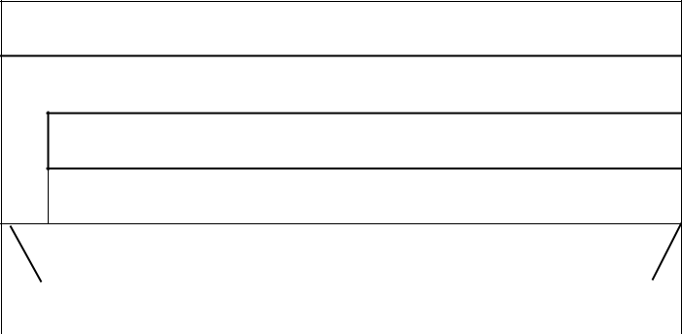

l:=false; t.first()

l t.end()

l, elem := t.current().bigger, t.current()

t.next()

l

temp=elem.contest | SKIP

Analogy: linear search, custom enumerator
- ~ Angler
cond(e) ~ a.bigger

Enumerator of Anglers²

enor(Angler) | first(), next(), current(), end()
tt : enor(Contest) | first() | ~ tt.first(); next()
cur : Angler | next() | ~ see below
end : | current() | ~ return cur
 | end() | ~ return end
Contest = rec (angler : String, contest : String, counter : ℕ)

In enor(Angler), operation next() has to solve the following task:

Tod o the decision, the enumerator of the first part can be used (enor(Contest)) which processes one

- The enumerator of Anglers, too, should be in a separate compilation unit.

OOP Sample documentation, 2nd assignment 4.

line of the input file and calculates how many catfishes the angler has caught on one contest. At the beginning of operation next(), the current item of the Contest enumerator is the first contest of the angler to be processed, so for getting tt.current(), tt.first() and tt.next() are not needed. The enumeration runs as long as the same angler’s contests are ”read” with tt.next().
_{A}next | = ( tt : enor(Contest) , cur : Angler, end : )
Pre^{next} = ( tt = tt’ )
Post^{next} = (= ′. () ∧ ¬ → ( . = ′. (). |  |  |  | ∧
 |  | . = .
 | ( . , ) = | ⋀ | ( .≥ 2))
 |  | ∈( ′. (), ′)
next()
 | end := tt.end()
 | _sx != norm
 | _end = false
 | cur.contest := _dx.contest  cur.bigger = true |  | SKIP
 | _sx := norm and cur.contest = _dx.contest
 | Curr.bigger = true cur.bigger = cur.bigger and _dx.bigger
 | tt.next()
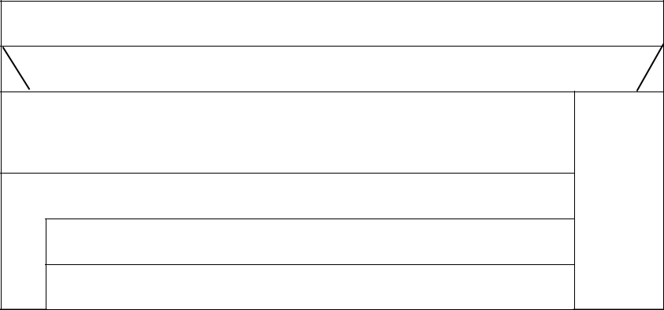

Analogy: summation (optimistic linear search), custom enumerator
t:enor(E) ~ tt:enor(Contest)
without first
as long as a.angler = cur.id
eϵt’ ~ a ϵ (tt’.current(),tt’)
- ~ cur.bigger
(H,+,0)~ ( , , true)

Testing

Three algorithmic patterns are used in the solution: linear search, optimistic linear search, and counting.

- Linear search in the first part:

– Searching for one angler who has caught at least 2 catfishes. – length-based:
    - Empty file.
    - One angler.
    - More anglers.
first and last-based:

- First angler has caught two catfishes.
- Only the last angler has caught two catfishes.
OOP Sample documentation, 2nd assignment 5.

pattern-based:
  - There is an angler who has caught big catfish.

  - There is no such angler.
  - There are more anglers who meet the requirements.

B. Number of the caught catfishes on one contest (counting) length-based:
  - Line without catches.
  - Line with one catch.
  - Line with more catches.
first and last-based:
- Line with catches, the first one is a catfish.

- Line with catches, the last one is a catfish. pattern-based:

    - Line without catfish catch.
    - Line with one catfish catch.
    - Line with more catfish catches.

C. Linear search in the second part:

– Searching for a skillful angler (who has caught at least two catfishes on each of his contests). –
length-based:
    - Empty file.
    - One angler.
    - More anglers.
first and last-based:
- There is bigger fish.
- Last one is bigger only.

